# MLP

## Get the best optimizer and learning rate

1. Adam with learning rate([1e-7,1e-6,1e-5,1e-4,1e-3])



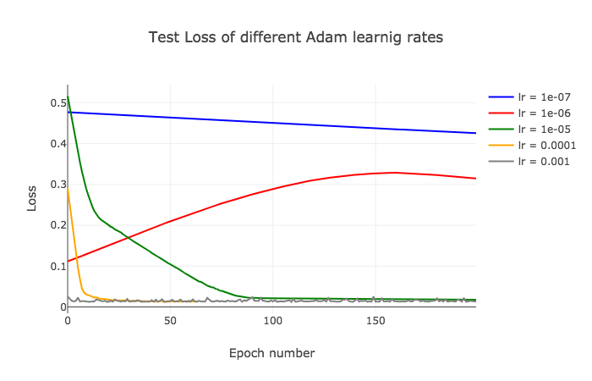



1. SGD with learning rate([1e-7,1e-6,1e-5,1e-4,1e-3])



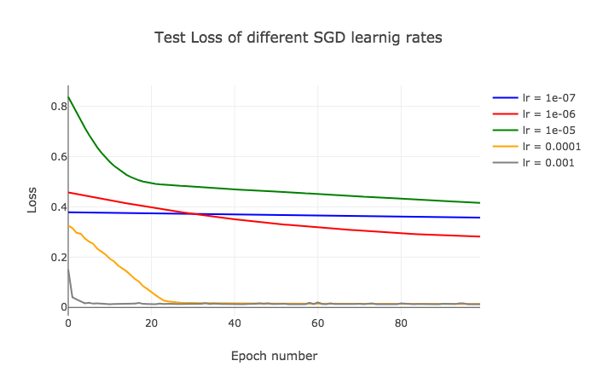



1. RMSprop with learning rate([1e-7,1e-6,1e-5,1e-4,1e-3])



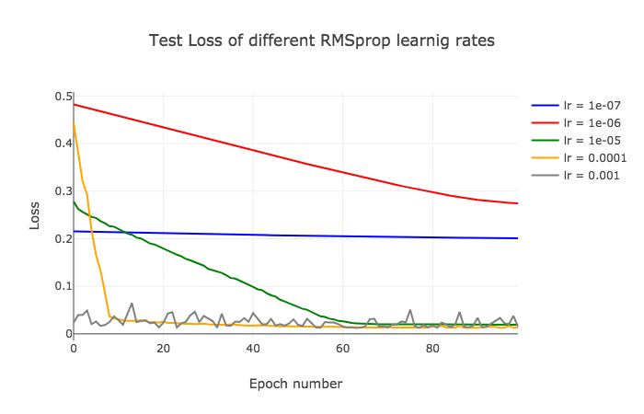



## RMSprop with learning rate as 0.001

1. Number of neurons: ([128,256,512])



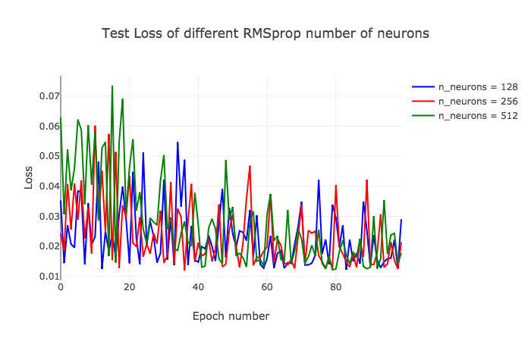



1. Number of layers: ([1,2,3])



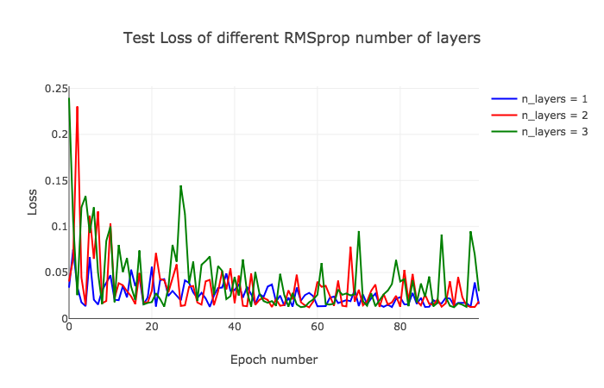



1. Batch_size: ([16,1,32,64])



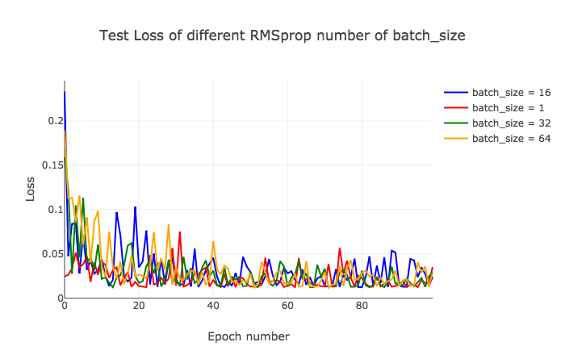



1. Drop_rate: ([0,0.25,0.5,0.75])



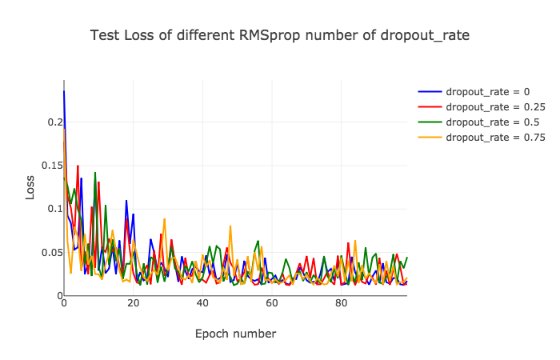



# LSTM

## Get the best optimizer and learning rate

1. Adam with learning rate([1e-7,1e-6,1e-5,1e-4,1e-3])



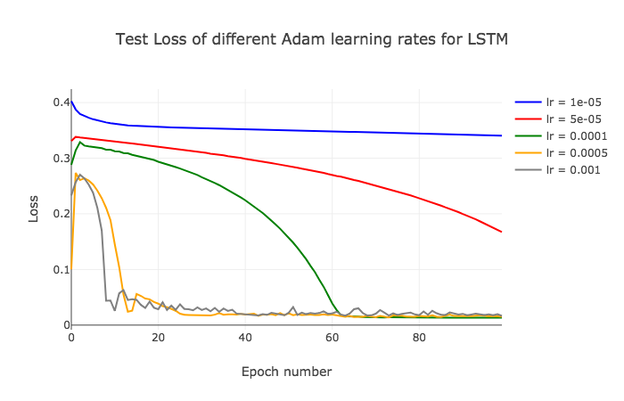



1. SGD with learning rate([1e-7,1e-6,1e-5,1e-4,1e-3])



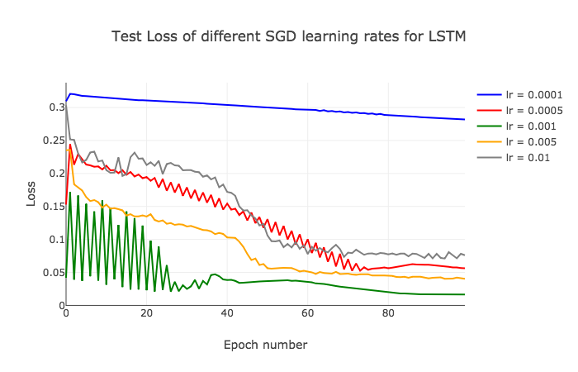



1. RMSprop with learning rate([1e-7,1e-6,1e-5,1e-4,1e-3])



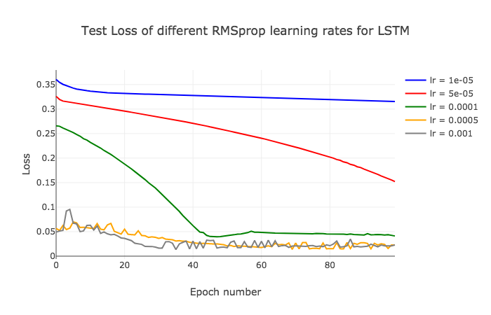



## Adam with learning rate as 0.0001

1. Number of neurons: ([128,256,512]):



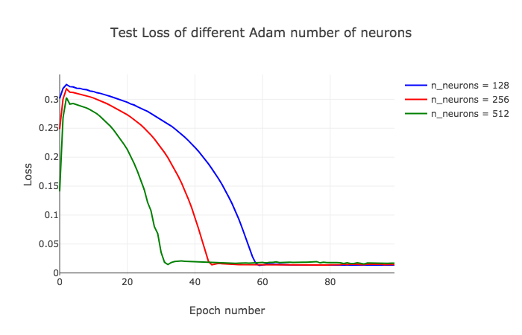



1. Number of layers: ([1,2,3])



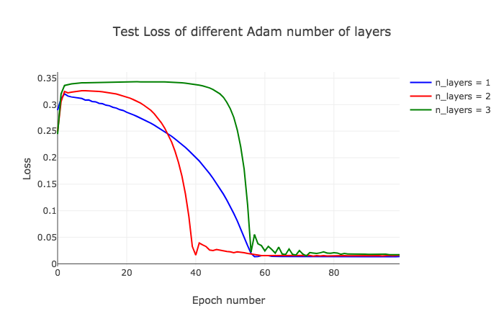



1. Batch_size: ([16,1,32,64])



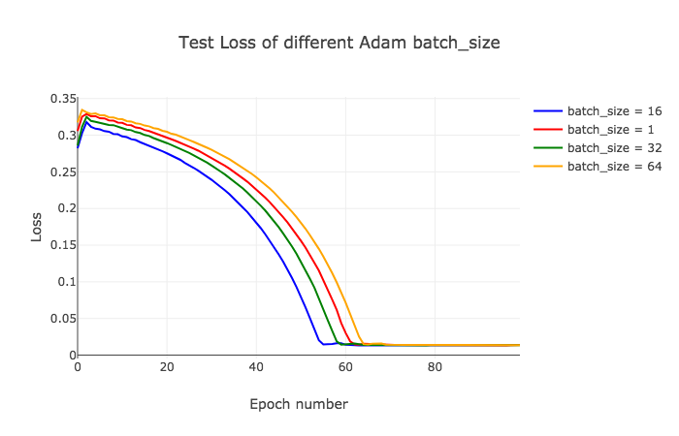



1. Drop_rate: ([0,0.25,0.5,0.75])



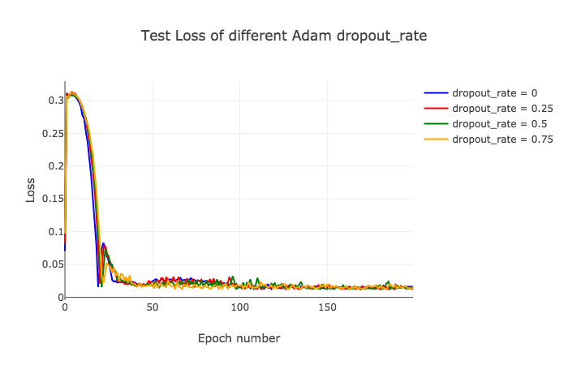



# GRU

## Get the best optimizer and learning rate

1. Adam with learning rate([1e-4,5e-4,1e-3,5e-3,1e-2])



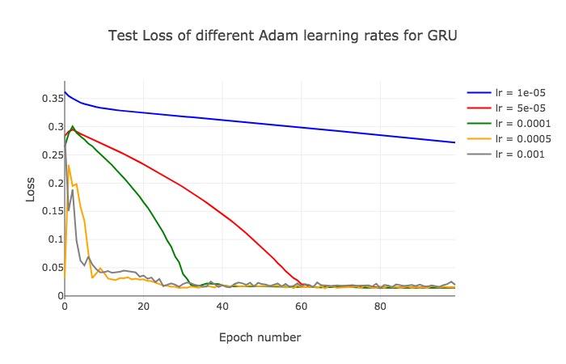



1. SGD with learning rate([1e-4,5e-4,1e-3,5e-3,1e-2])



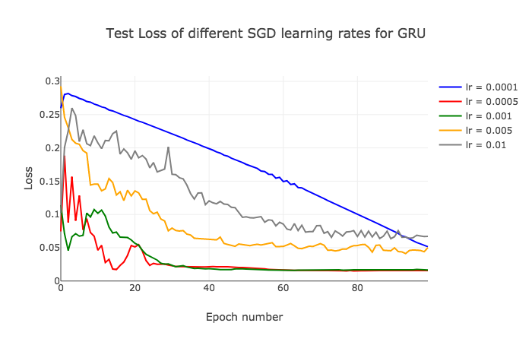



1. RMSprop with learning rate([1e-4,5e-4,1e-3,5e-3,1e-2])



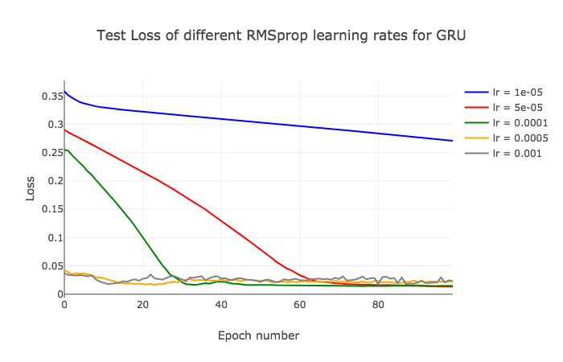



## RMSprop with learning rate as 5e-5

1. Number of neurons: ([128,256,512]):



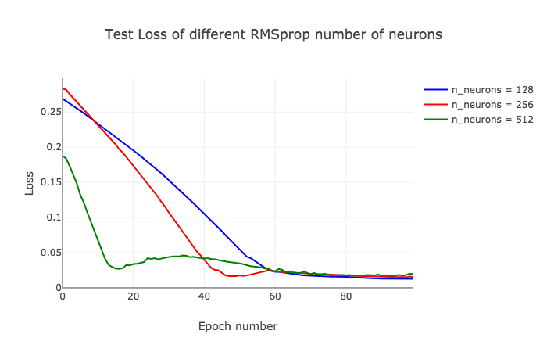



1. Number of layers: ([1,2,3])



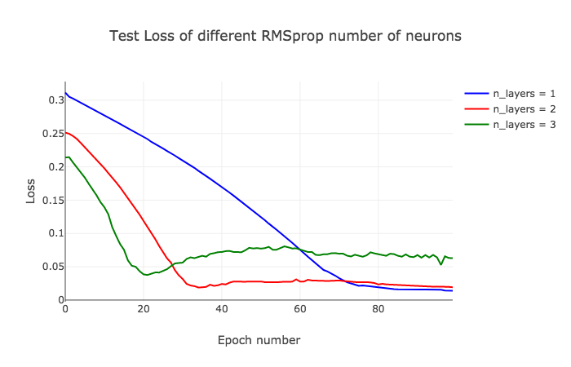



1. Batch_size: ([16,1,32,64])



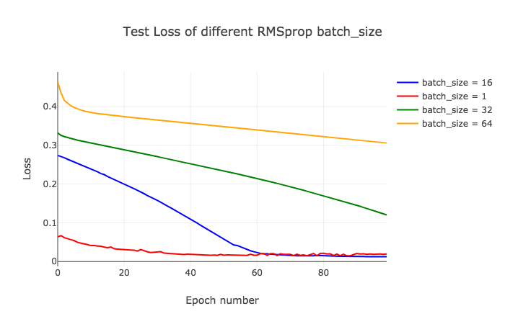



1. Drop_rate: ([0,0.25,0.5,0.75])



